**Identification of Danger Zone on Construction Site Based on CV**

B07501113 林庭瑄、B07501046 陳蓮安、B07501106 彭永椿、D07521003 徐瑋澤、D10521039 杜雨晨

1. **Introduction**

As we all know , construction is one of the most dangerous industries.At least 108 thousand workers are killed on site every year, a figure which represents about 30% of all occupational fatal injuries.Data from a number of industrialized countries show that construction workers are 3 to 4 times more likely than other workers to die from accidents at work. In the developing world, the risks associated with construction work may be 3 to 6 times greater (ILO, 2015).Figure 1 shows the situation of construction industry disasters in Taiwan in recent years.Although the trend of disasters has declined，occupational deaths in construction still account for almost half of all industries.Data from Taiwan's labor department indicates that the main types of accidents are falls, puncture、incised wound and graze，in addition，the number of occupational disaster deaths in Taiwan's construction industry accounted for 46% of all industries in 2020 (OSHA , 2021).The types of accidents in the construction industry in Hong Kong are similar to those in Taiwan.The most accidents in Hong Kong's construction industry are mainly slip, trip, fall on the same level and falling from height can easily cause death (Labour Department, 2021).At the same time, we found a number of cases in which workers fell and were punctured by rebars, resulting in serious injuries.Although the law stipulates that employers should take protective measures such as bending tips, adding covers or adding sheaths for those exposed in the workplace, such as steel bars, steel, iron, aluminum and other materials that are prone to occupational hazards (Ministry of Labor , 2021), monitoring and management on construction sites is still a hard work due to its clutter and disorder.

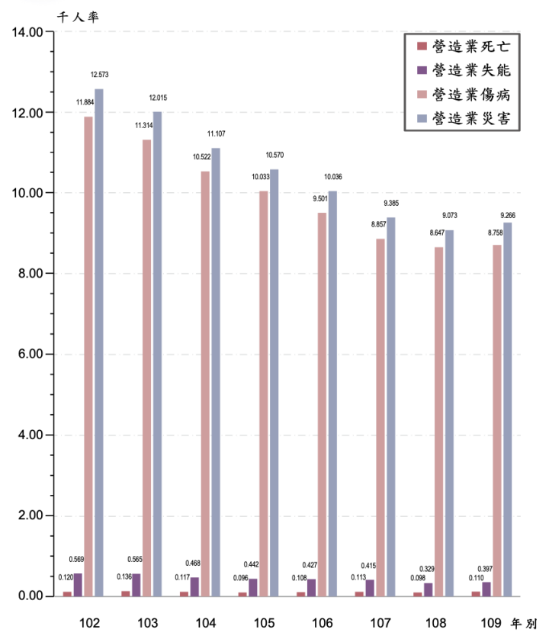 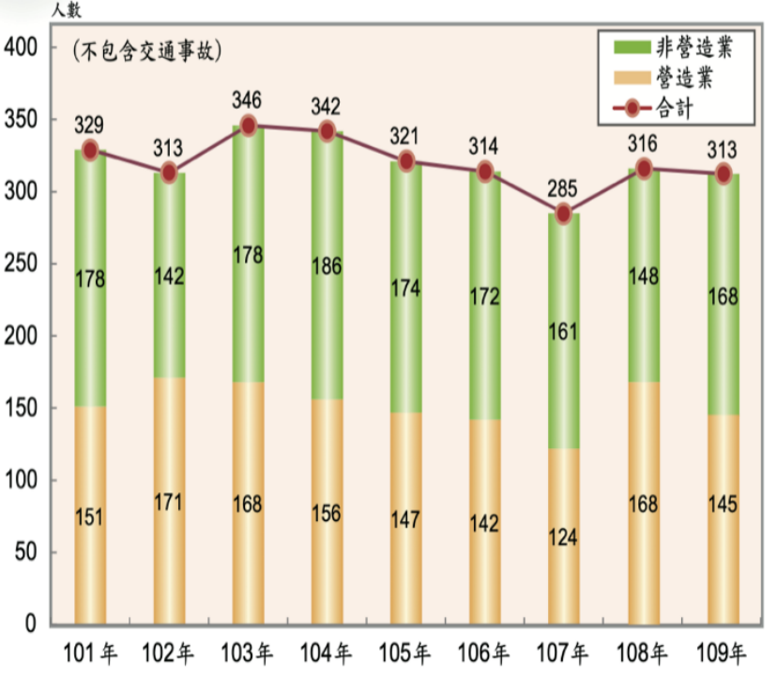

Figure 1.Casualties in Taiwan's construction industry in recent years

(OSHA , 2021)

More and more studies have proved the significance of computer vision in assisting construction site management. The researchers mainly focus on four aspects, including safety、progress、productivity and quality (Xu, et al, 2020).Due to the multiple accidents and the importance of life safety, our study will focus on the aspect of safety. The purpose of our research this time is to identify dangerous areas on construction sites automatically , such as identifying whether rebars are well protected or not.We hope to use computer vision to improve the efficiency of safety supervision, prevent accidents and ensure the safety of workers.

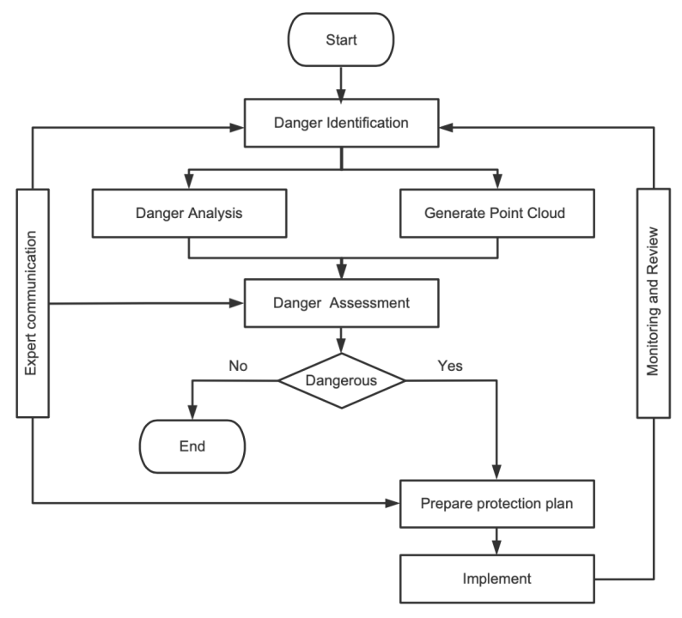

Figure 2. Research process

With reference to ISO 31000 standards, we set up the research process which is shown in Figure 2 .First , We used smartphone to get 2D images of the construction site，Then identify the danger zone and build point cloud.If the assessment is dangerous, it will be reported to us and workers can then establish protection. Finally, continue monitoring until all areas are safe.

1. **Method**
2. Data pre-processing

In this section, we want to emphasize categorical features to describe our data and teach the machine to know where the danger zone is. Generally, a danger zone is an area on a construction site with a high possibility of slips, trips, falls, being struck by something, etc. In our data set, we divided them into three major cases: unbounded/ unclosed pits and zones with a high possibility of falling. The one that we want to emphasize the most in our project is steel rod reinforcement that sticks out and is not covered, and this is very dangerous if someone falls or slips over it.

Next, we want to categorize to let the machine know which area is dangerous, and we also need to know which area is the opposite. Some measures could be taken if we want to make the initially dangerous area less dangerous. For example, separating or bounding places with a high possibility of an accident could decrease the risk a lot. If there is any measure to make the danger zone less dangerous, we can let the machine categorize them as safe now.

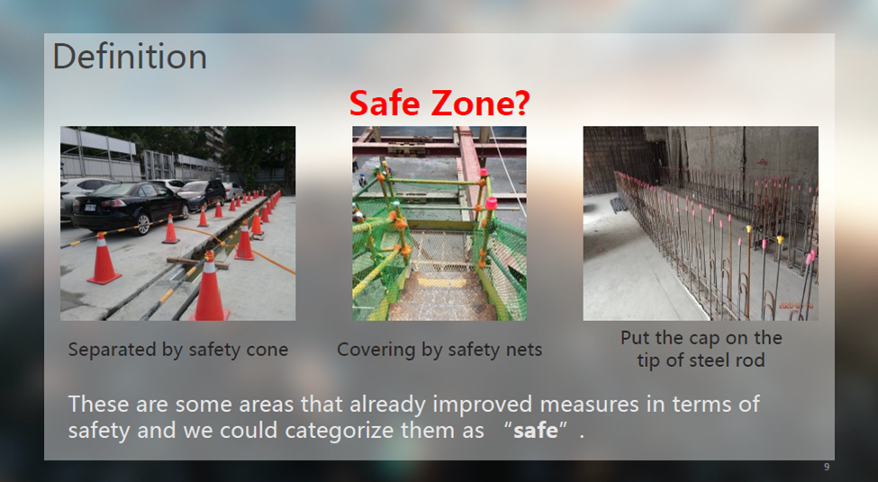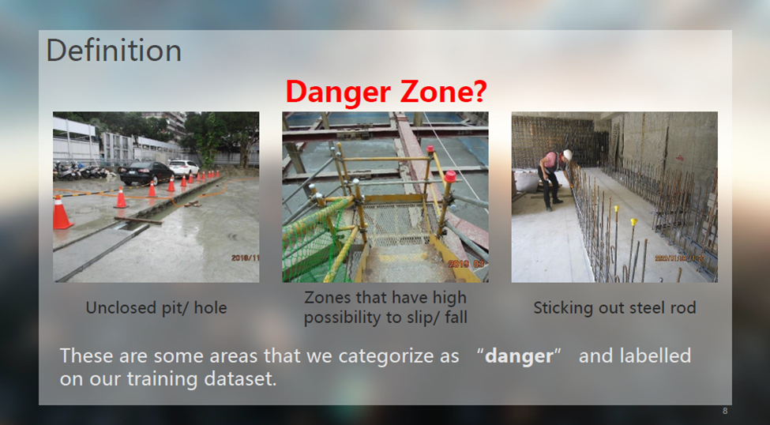

Fig?. Danger and Safe Zones Definition

We collected around 362 images and treated them as our raw data set. These images were taken between 2018-2022 from several construction sites in Taipei. It is taken in the range of 4 years because we want to compare these danger zones before and after being applied with safety measures.

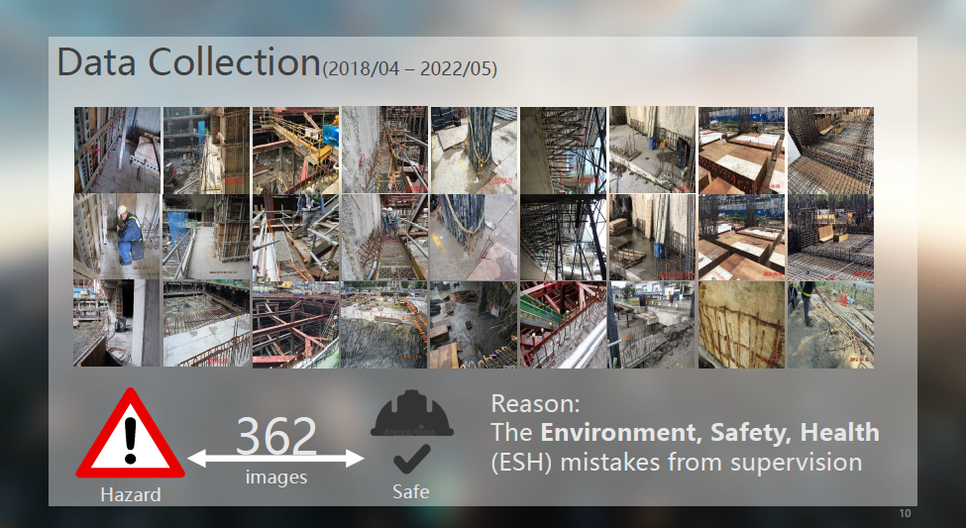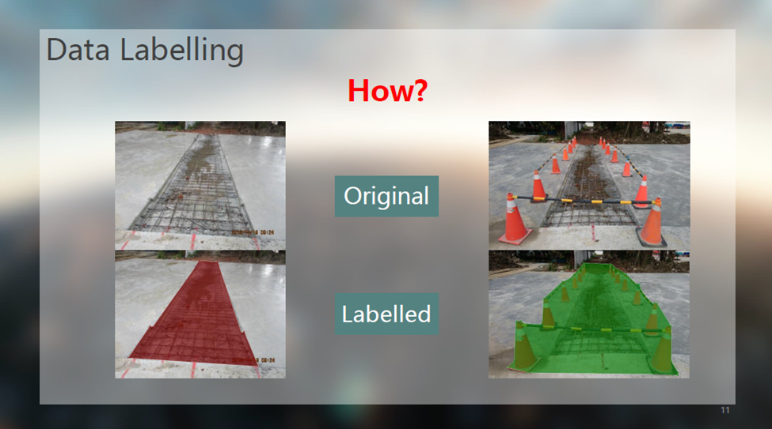

Fig X-X. Data Labelling

The next stage is to label each picture from our data set. It has to be done because we do not have a vast data set that we can work on. Furthermore, labeling a sample dataset is the best way to explore because we give an immediate decision for each image and could give a good insight into human performance and the obstacles our model might face. Hence, we utilized a widely used program for image labeling called labelme. First, we label every single one of the raw images and let the machine know which part of the picture can be categorized as dangerous or not. After this labeling process, we then pass the pre-processed data to train them.

1. Model training

After data labeling, we have 360 image-mask pairs as our training data. In order to find potentially dangerous areas, we train an instance segmentation model to detect those areas automatically. There are mainly four types of tasks in the graphics application of machine learning. Image recognition is simply identifying objects in the image, while object detection marks their location with a bounding box. Semantic segmentation and instance segmentation both need to classify every pixel in the image. The difference between them is that instance segmentation distinguishes each individual while semantic segmentation does not.

In our application, both semantic segmentation and instance segmentation models meet the requirements. Considering the robustness and the accessibility of open source code, we chose Mask R-CNN as our training model, which had pre-trained on the COCO dataset. Additionally, the following graph shows that we get the predicted bounding box and the mask simultaneously when using the Mask R-CNN model, which makes it easier for the model to define the correct object boundaries. The Coco dataset is the abbreviation of Common Object in Context, a large-scale labeled image dataset available for public use. Following are some image-mask pairs in the coco dataset. We can see that there is a specific color for each class.

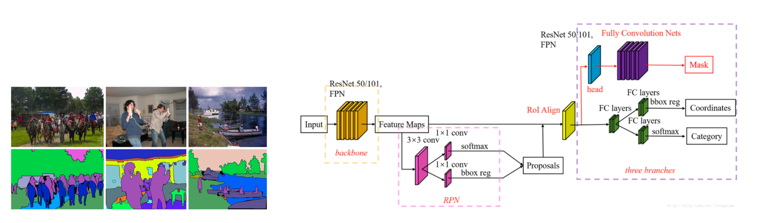

Fig X-X. Mask R-CNN Model

The following is the summary of the details of model training.

* dataset: 360 labeled photos (50 validation + 310 training)
* optimizer: SGD optimizer , learning rate = 0.01, momentum = 0.9, weight_decay=0.001
* learning rate scheduler: learning rate scheduler which decreases the learning rate by 20 times every 10 epochs

It’s noted that we do not need to add a mean or standard normalization nor image rescaling in the data transforms, as those are handled internally by the Mask R-CNN model. At last, we run 30 epochs and get Average Precision (AP) = 0.419 in semantic segmentation task.

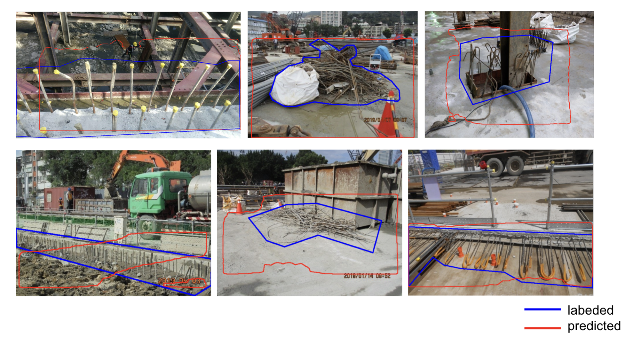

Fig. ? predicted results

By applying the model to images collected from a room under construction, we can predict the potential danger zones by setting the confidence value to 0.85.

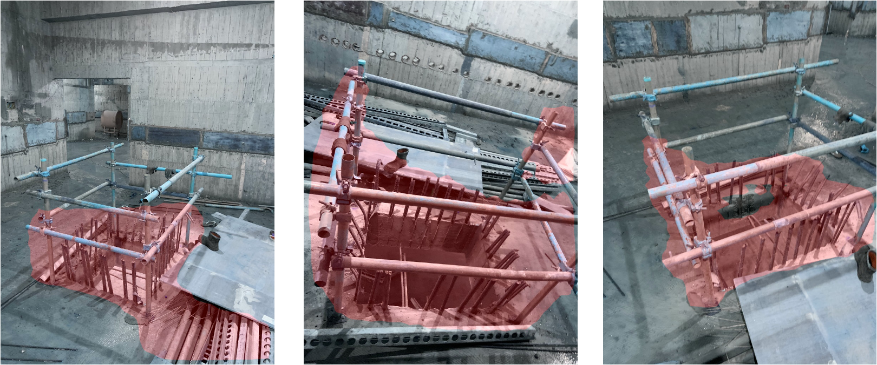

Fig. ? predicted results of the room

1. Point Cloud Simulation

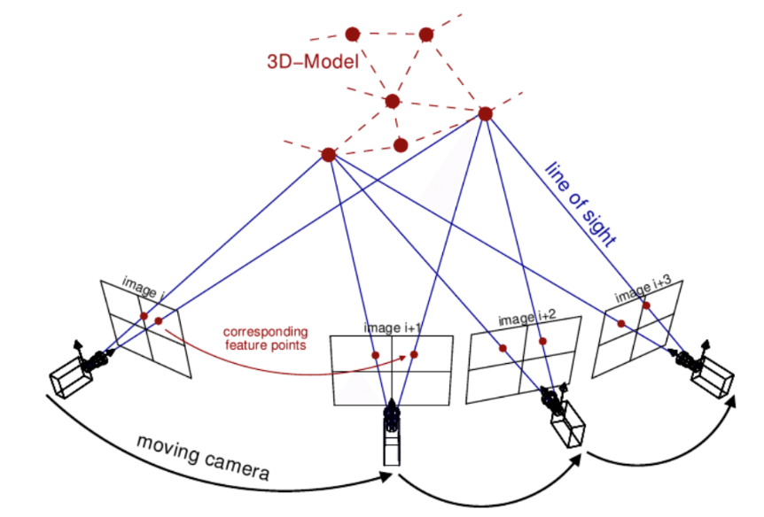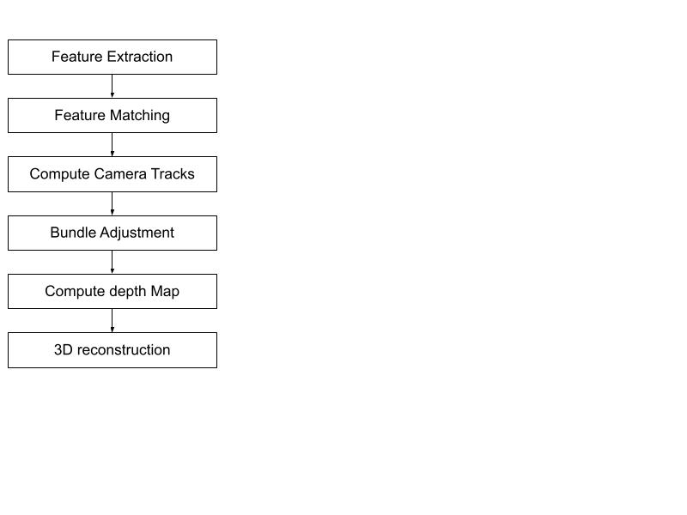

We use open SFM to generate the point cloud. By extracting the features of the images and matching them together, Then computing the camera tracks of the photos to make bundle adjustments. Then calculate the depth map of every image to get the 3d location of the pixels in the images to generate the point cloud.

However, the point cloud may be dense in some areas and sparse in others due to the number of images and the number of matched features. So we will use a voxel downsampling method to ensure there is only one point inside every voxel. For this room, we set the voxel size to four centimeters, and the total number of points decreased from 14,704,356 to 2,367,650, only 16% were retained.

Another problem is that there are points that are not in the correct position, which are called outliers. So we will use DBSCAN to identify which points are close enough to others. The eps value is set to 30 centimeters and the minimum number of points value is set to 200. The points that are too far away from the room itself are deleted, And the points inside the room but too far from the actual objects are also deleted, so the point cloud looks a lot cleaner

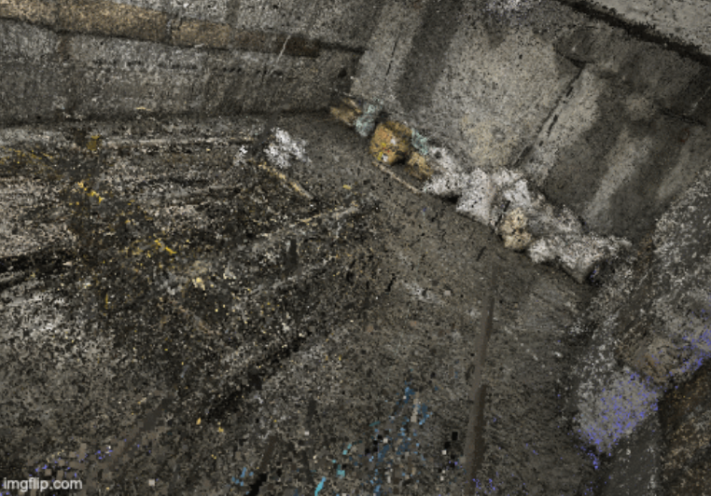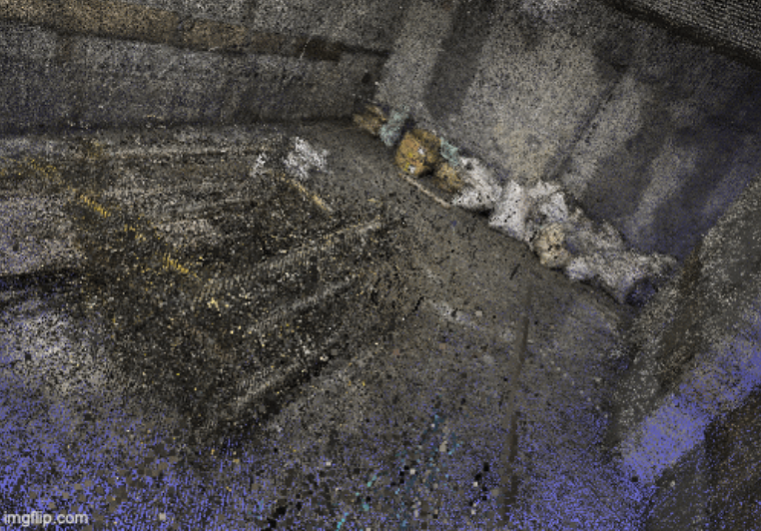

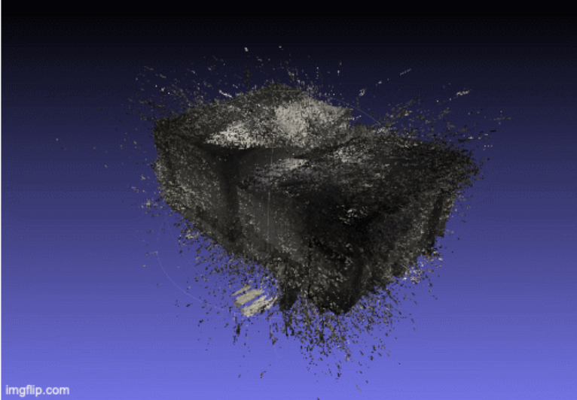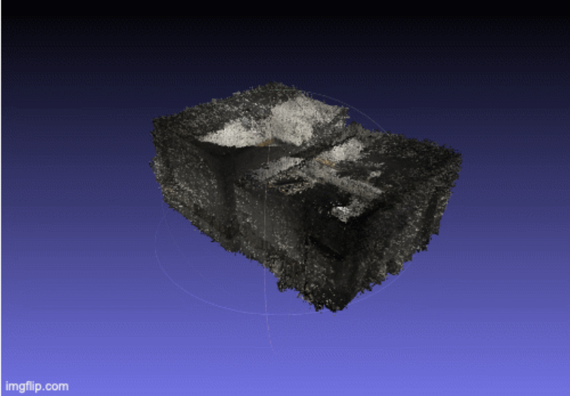

Original Point Cloud Point Cloud after Preprocessing

Fig. ?

Then we will create the semantic segmentation of the point cloud using the depth map of every image and its semantic segmentation masks that are predicted. The masks are composed of the color black and red, with black meaning safe and red meaning danger. So the red points in the point clouds are the dangerous points.

However, there may be some incorrect predictions of semantic segmentation models or a wrong depth map generated from OpenSFM. So for the last step, we will use the Dbscan again on the semantic segmentation of the point cloud to extract the dangerous points that are dense enough. The blue points result from dbscan applied to the red points with the esp value set to 20 centimeters and the min points set to 100.

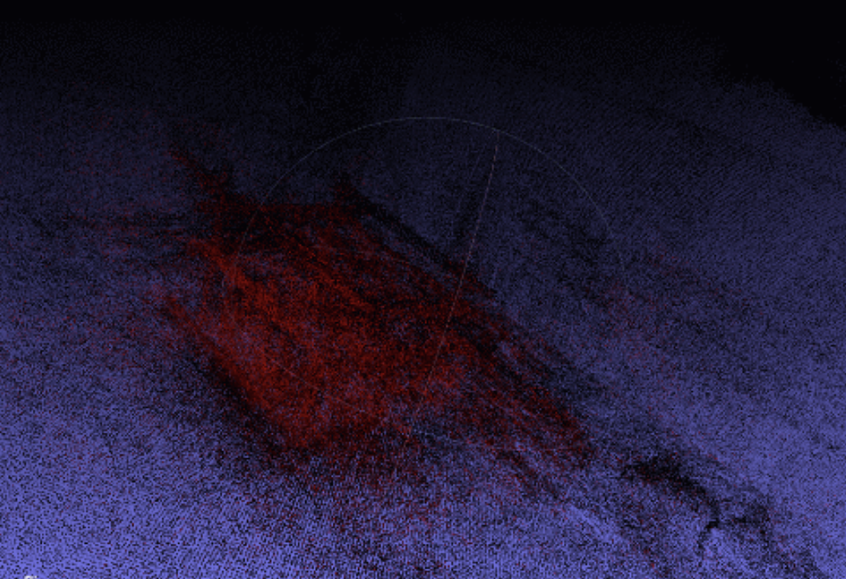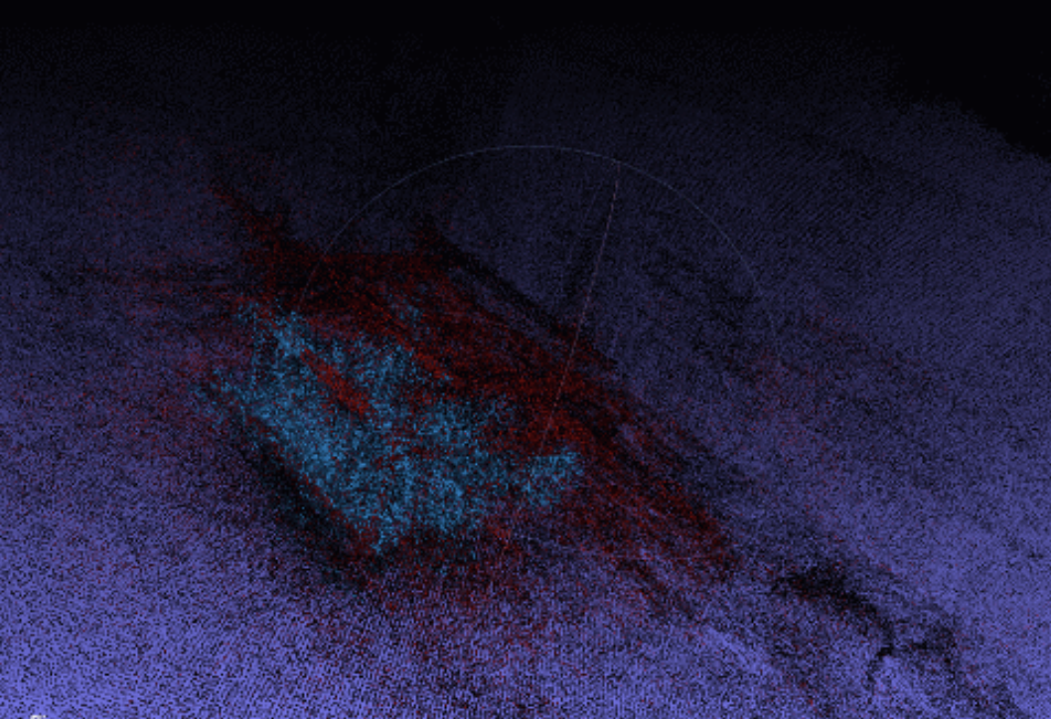

Semantic Segmentation of Point Cloud Extracted Danger Zone of Point Cloud

Fig. ?

1. **Conclusion**
2. **References**
3. Kim, H., Lee, H. S., Park, M., Chung, B., & Hwang, S. (2016). Automated hazardous area identification using laborers' actual and optimal routes. Automation in Construction, 65, 21-32.
4. ILO. (2015). Construction: a hazardous work. <https://www.ilo.org/global/topics/safety-and-health-at-work/areasofwork/hazardous-work/WCMS_356576/lang--en/index.htm>
5. ISO. (2009). ISO 31000:2009(en)Risk management -Principles and Guidelines.https://www.isa.org.jm/files/files/documents/asnzs_31000_2009.pdf
6. Jovanović, J. M., Aranđelović, M., & Jovanović, M. (2004). Multidisciplinar aspects of occupational accidents and injuries. Facta universitatis-series: Working and Living Environmental Protection, 2(4), 325-333.
7. Labour Department. (2021). Summary of Occupational Safety and Health Statistics. <https://www.labour.gov.hk/common/osh/pdf/archive/statistics/OSH_Statistics_2020_tc.pdf>
8. OSHA. (2021). https://www.osha.gov.tw/media/7188732/109勞動檢查統計年報-全一冊.pdf
9. Othman, I., Majid, R., Mohamad, H., Shafiq, N., & Napiah, M. (2018). Variety of accident causes in construction industry. In MATEC Web of Conferences (Vol. 203, p. 02006). EDP Sciences.
10. Xu, S., Wang, J., Shou, W., Ngo, T., Sadick, A. M., & Wang, X. (2021). Computer vision techniques in construction: a critical review. Archives of Computational Methods in Engineering, 28(5), 3383-3397.
11. Structure From Motion <https://opensfm.org/docs/using.html> , <https://www.researchgate.net/publication/303824023_Exploring_the_use_of_3D_GIS_as_an_analytical_tool_in_archaeological_excavation_practice>
12. Down Sample <http://www.open3d.org/docs/release/tutorial/geometry/pointcloud.html>
13. DBSCAN https://zh.wikipedia.org/wiki/DBSCAN, <https://towardsdatascience.com/how-dbscan-works-and-why-should-i-use-it-443b4a191c80>